ICU Emergency: Learning Quiz

- You assess your patient and find the O2 saturation is now 85%. It had been running 94% on 2 liters nasal cannula. The patient does have orders to titrate the oxygen according to their O2 Sat. What should be your first action?
  - Increase the oxygen to 4 liters nasal cannula
  - Get stat arterial blood gases
  - Call the MD
  - Check the blood pressure

- Identify the rhythm:
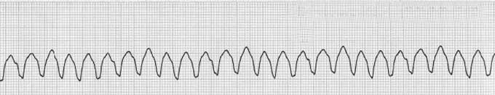
  - Ventricular fibrillation
  - Sinus Tachycardia
  - Ventricular tachycardia

- Which is the first drug of choice when treating Ventricular fibrillation or pulseless
ventricular tachycardia?
  - Atropine push
  - Epinephrine IV push
  - Amiodarone IVPB
  - Dopamine drip

- What is the most common cause of pulseless electrical activity?
  - Hypothermia
  - Hypoxia
  - Hypovolemia
  - Hypoglycemia

- True or False. A stat chest x-ray should always be done to verify placement of the ET tube, post intubation.

- Review the following three rhythms. Which rhythm is Ventricular fibrillation and requires immediate attention?

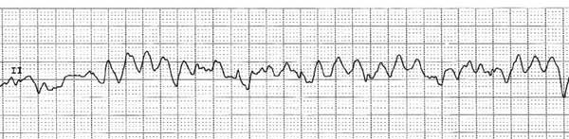

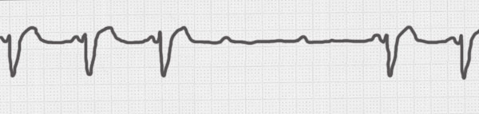

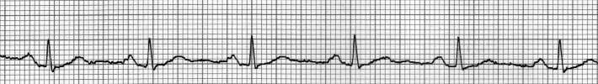

- The treatment of choice for Second Degree AV block Type 2, and Complete Heart Block (3rd degree clock) is:

  - Administer Epinephrine
  - Begin CPR
  - Transcutaneous pacing or transvenous pacing
  - Defibrillation

- Which of the below scenarios most describe a patient with symptomatic bradycardia and requires your immediate attention?

  - Heart rate is 45 bpm, patient is sleeping, and blood pressure is 90/64
  - Heart rate is 52 bpm, blood pressure is 80/50, and patient is cool and clammy
  - Heart rate is 48 bpm, patient is eating breakfast, and blood pressure is 110/60

- You are assisting with a code blue and the patient had been found in asystole, you know from what you have learned that the first course of action for asystole is:

  - Give Epinephrine
  - Start CPR immediately
  - Shock the rhythm

- You are working a telemetry floor, the monitor tech calls you to check Mrs. Jones, since her leads are off and the monitor is showing a straight line. You find her unresponsive. What is your most appropriate set of actions to do FIRST?

- Call for help and the crash cart, start CPR
- Put oxygen on her and wait for help to come to the room
- Check her IV, put oxygen on and the start CPR.

- Identify the rhythm?
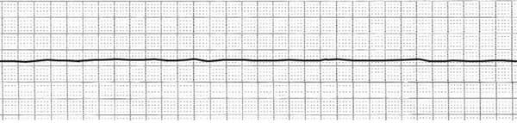
  - Ventricular fibrillation
  - Asystole
  - Ventricular tachycardia
  - Sinus rhythm

- Identify the rhythm:

  - Ventricular Fibrillation
  - Asystole
  - Ventricular tachycardia
  - Sinus Rhythm

